**Report**

1. **Swing**

**1.1 AWTAccumulator**

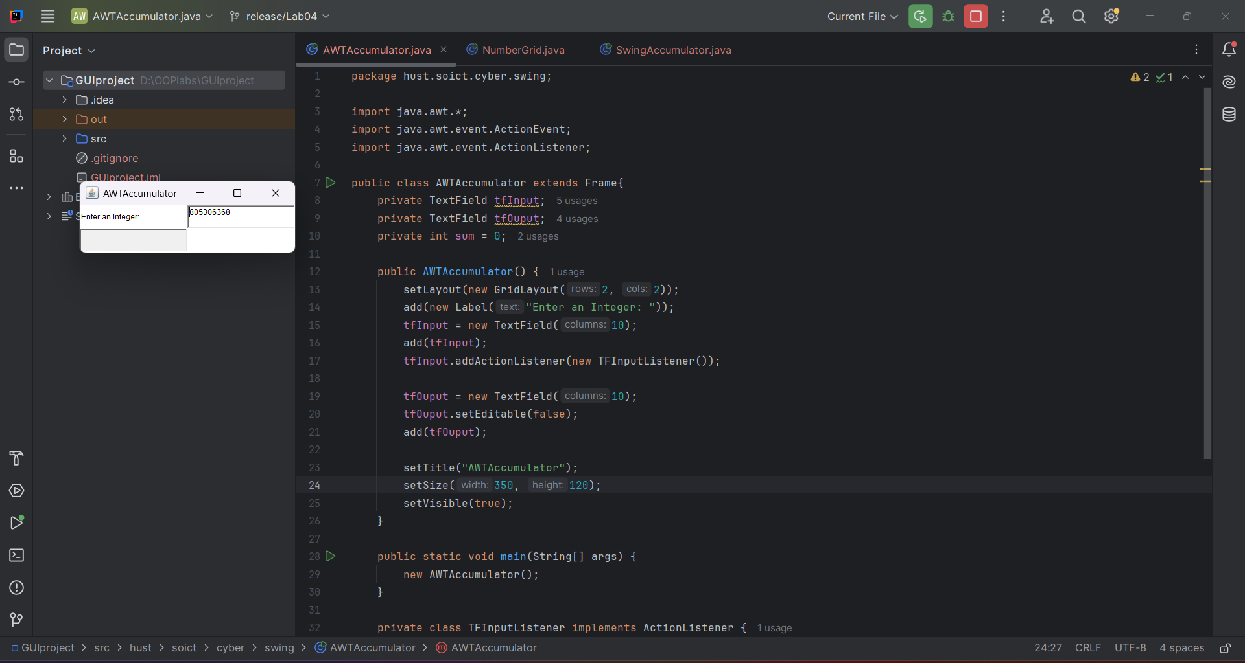

**1.2. SwingAccumulator**

1. **Organizing Swing components with Layout Managers**

1. **Create a graphical user interface for AIMS with Swing**

3.2 StoreScreen class** 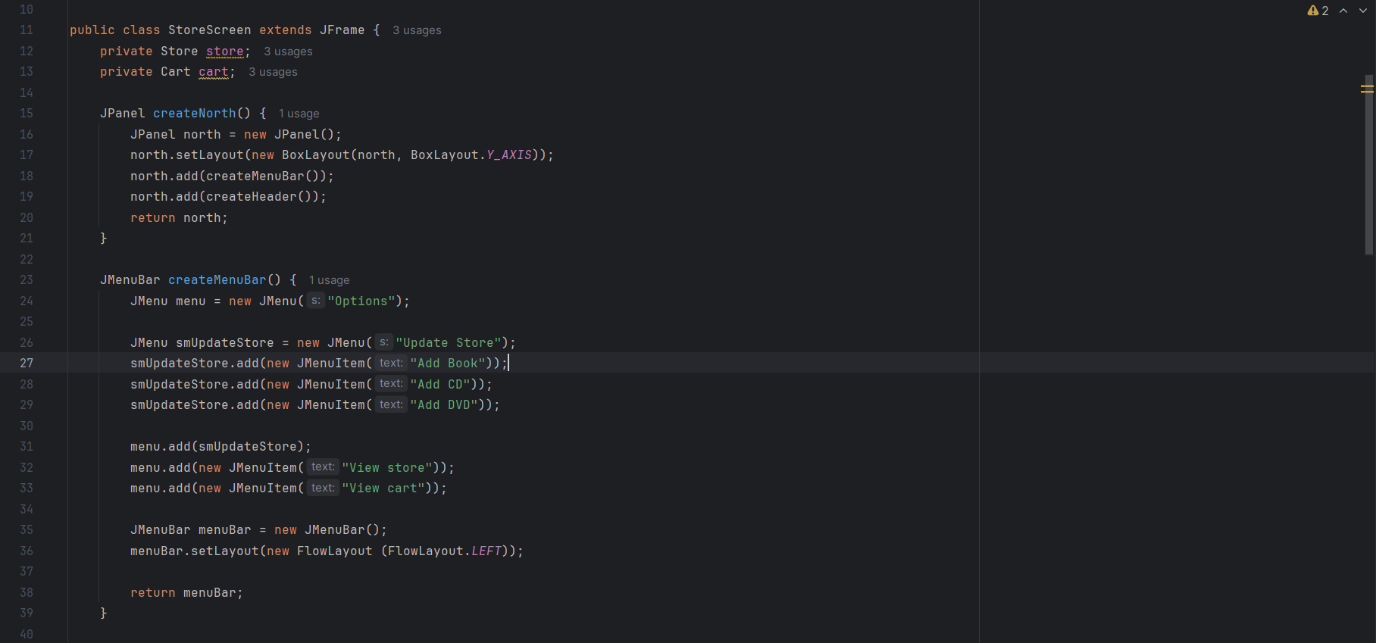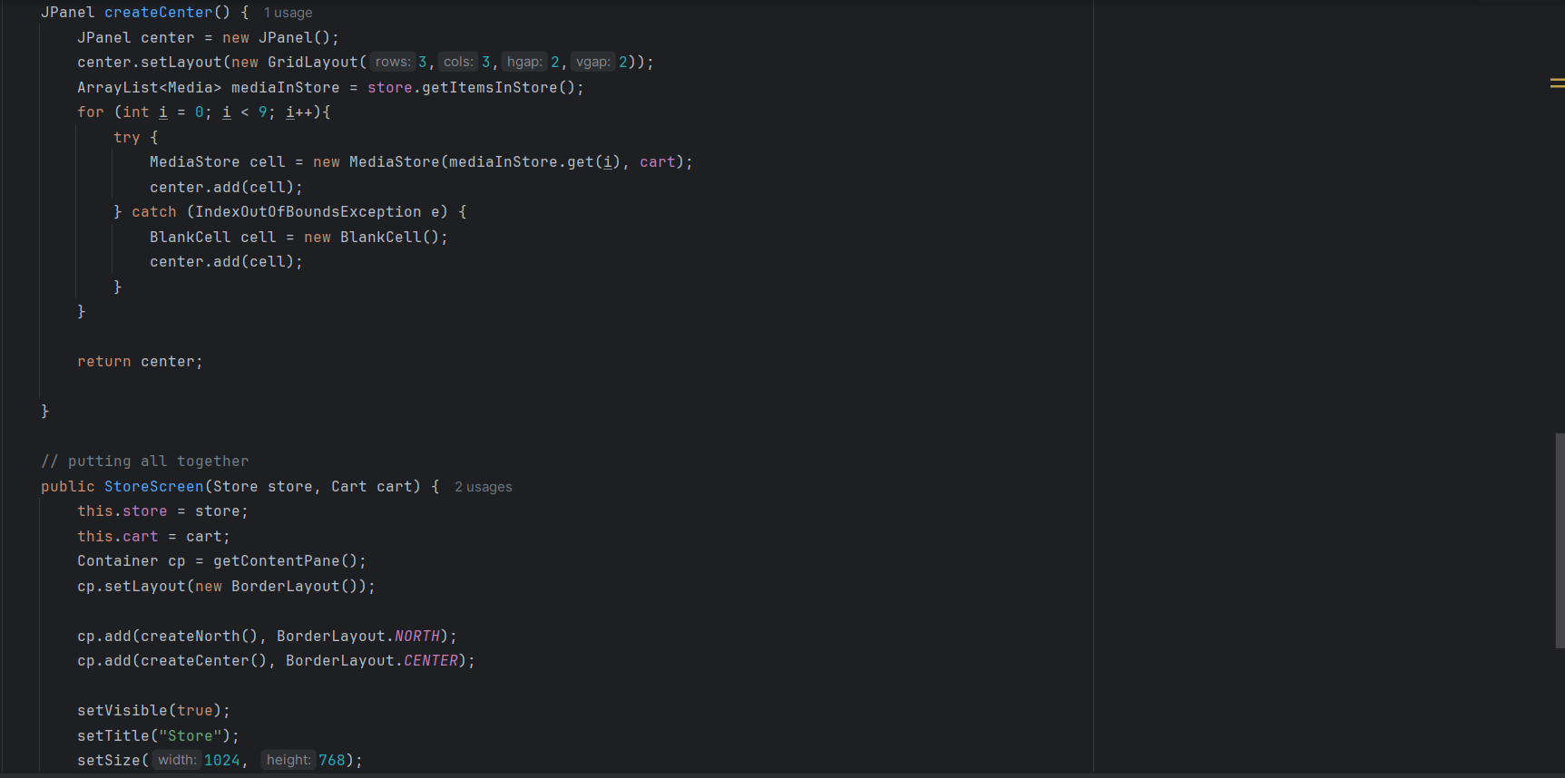

**3.3 The MediaStore class**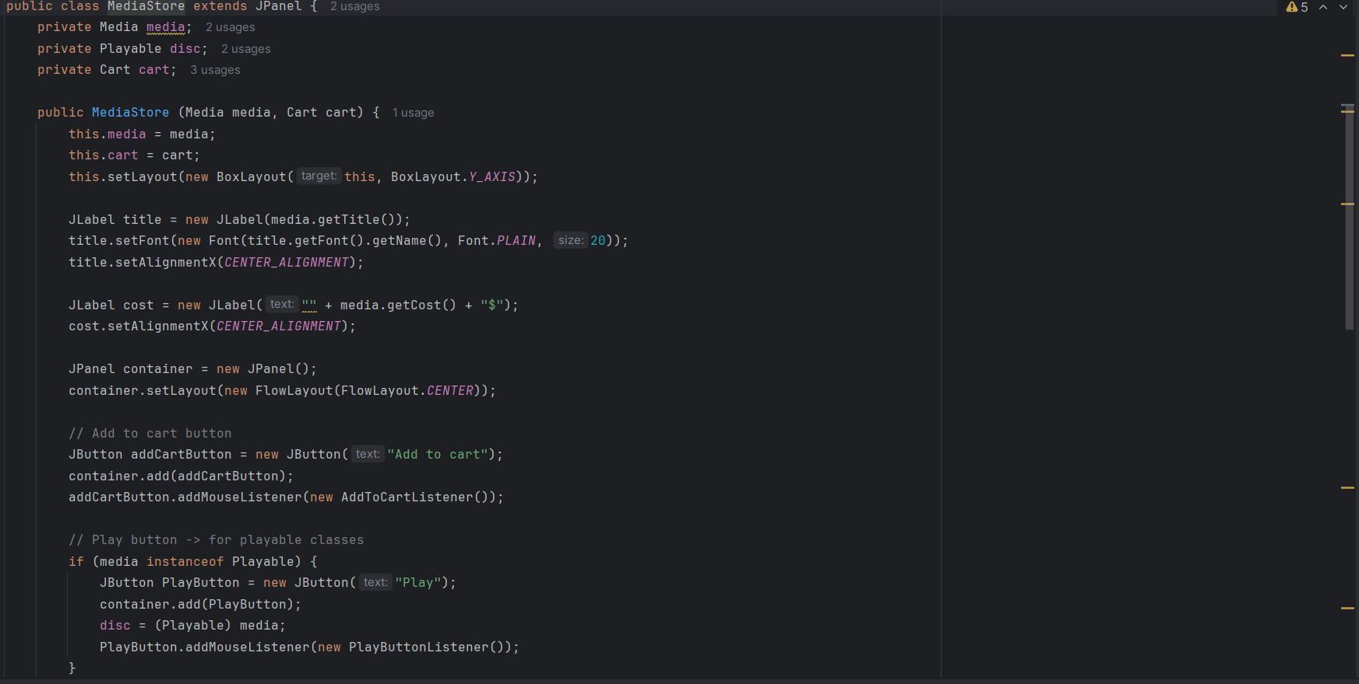

1. **JavaFX API**

1. **Setting up the View Cart Screen with ScreenBuilder**

1. **Integrating JavaFX into Swing application – The JFXPanel class**A screenshot of a computer program

   Description automatically generated
2. **View the items in cart – JavaFX’s data-driven UI**

**- Update itemsOrdered to ObservableList**

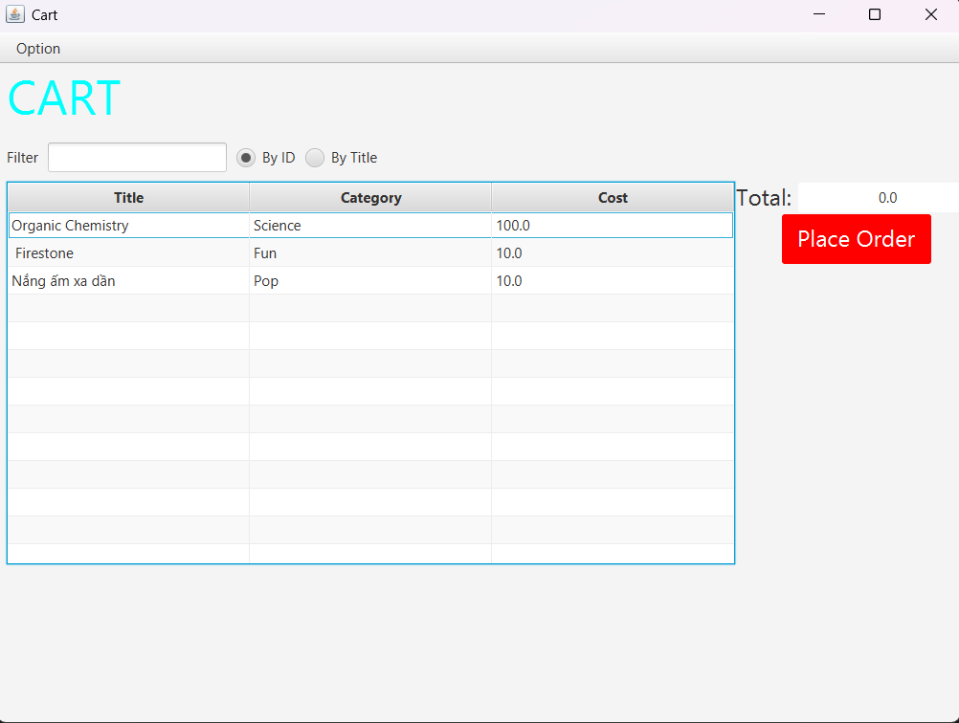

1. **Updating buttons based on selected item in TableView – ChangeListener**

1. **Deleting a media**

**10. Filter items in cart – FilteredList**

**11. Complete the Aims GUI application**

* Search

AddItemToStoreScreen code:

AddBookToStoreScreen code:

AddCompactDiscToStoreScreen code:

AddDigitalVideoDiscToStoreScreen code:

**12. Check all the previous source codes to catch/handle/delegate runtime exceptions**

**13. Create a class which inherits from Exception**

**CD**

**DVD**

**Track**

**14. Update the Aims class**

**15. Modify the equals() method of Media class**

**17. Update Aims class diagram**

